1. Let 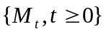 with 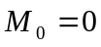 be a continuous martingale w.r.t {ℱ,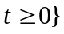 which is right-continuous. Define 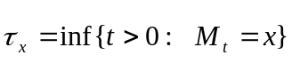. For 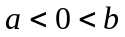,
prove that
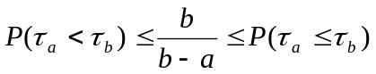;
.

2. 1°) If is a 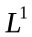-bounded martingale w.r.t {ℱ,, prove that for each t the limits
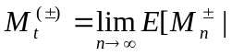 ℱ]
exist a.s. and the processes 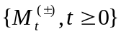thus defined are positive martingales.
2°) If the filtration is right-continuous and complete, prove that a right-continuous
martingale M is bounded in iff it can be written as the difference of two right-continuous with left-limits positive martingales 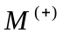and 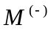.
3°) Prove that and may be chosen to satisfy
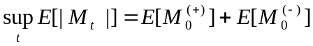
in which case the decomposition is unique (up to indistinguishability).
4°) The uniqueness property extends in the following way: if Y and Z are two
positive martingales such that M = Y - Z, then 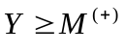 and 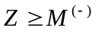, where 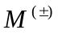are the martingales of 3°).

